文藻外語大學校旗暨校錦旗申請表
Application form for Wenzao flag and banner
申請物品 Items
校旗 數量：______ 面 (金額：350元/面)  Wenzao Flag Quantity: (NT$350/each)  尺寸：87公分*138公分 Dimensions:87x138cm  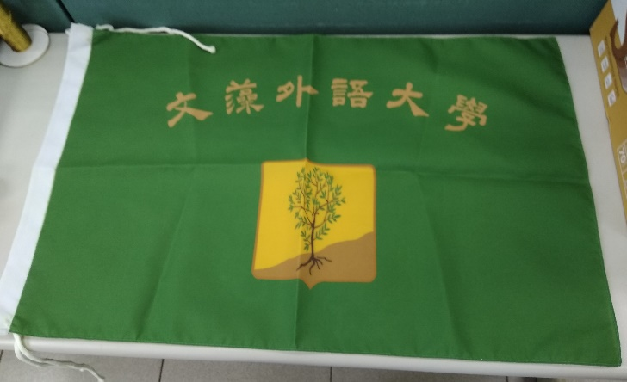 |  | 校錦旗 數量：______ 面(金額：140元/面)  Wenzao Banner Quantity: (NT$140/each)  尺寸：46公分*28公分 Dimensions:46x28cm  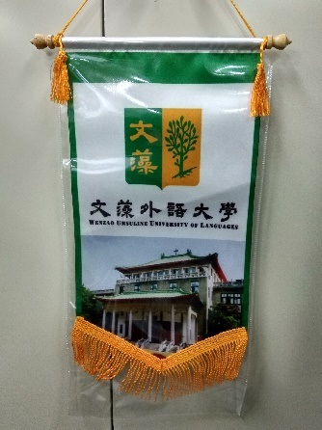
申請需求 Requirements
借用 Borrowing (例：服務隊營期借用off-campus service work)
領用Collecting (例：致贈姊妹校、貴賓等 as a gift to partner schools or guests)
用途說明 Reason for Application
自行付費 Paid by a user 申請免付費 Apply for free use
說明(Note)：

申請單位 Application Unit
申請人 Applicant | 二級主管 Unit Head |  | 一級主管 Unit Head
管理單位  Management Unit | 事務組  Purchasing & Supply Section |  | 總務處  Office of General Affairs
決行單位  Approved by | 主秘辦公室  Office of Secretariat |  | 行政副校長室  Office of Vice President for Administrative Affairs
收費蓋章
Stamped upon payment
領用/借用日期 Borrowing date | 領用/借用人簽章 Signature( borrower) |  | 備註 Remark
歸還日期 Return date | 收取人簽章 Signature (receiver) |  | 備註 Remark
總務處製表
2018.06.20

